## UI design

### Ordering System

1. Homepage

All products showed in ‘HOT PRODUCTS’ are sorted by the remaining stock of all variants of each product. On the top of the page, the username will be shown if the user has already logged in. Otherwise, there will be a LOGIN bar to click instead. 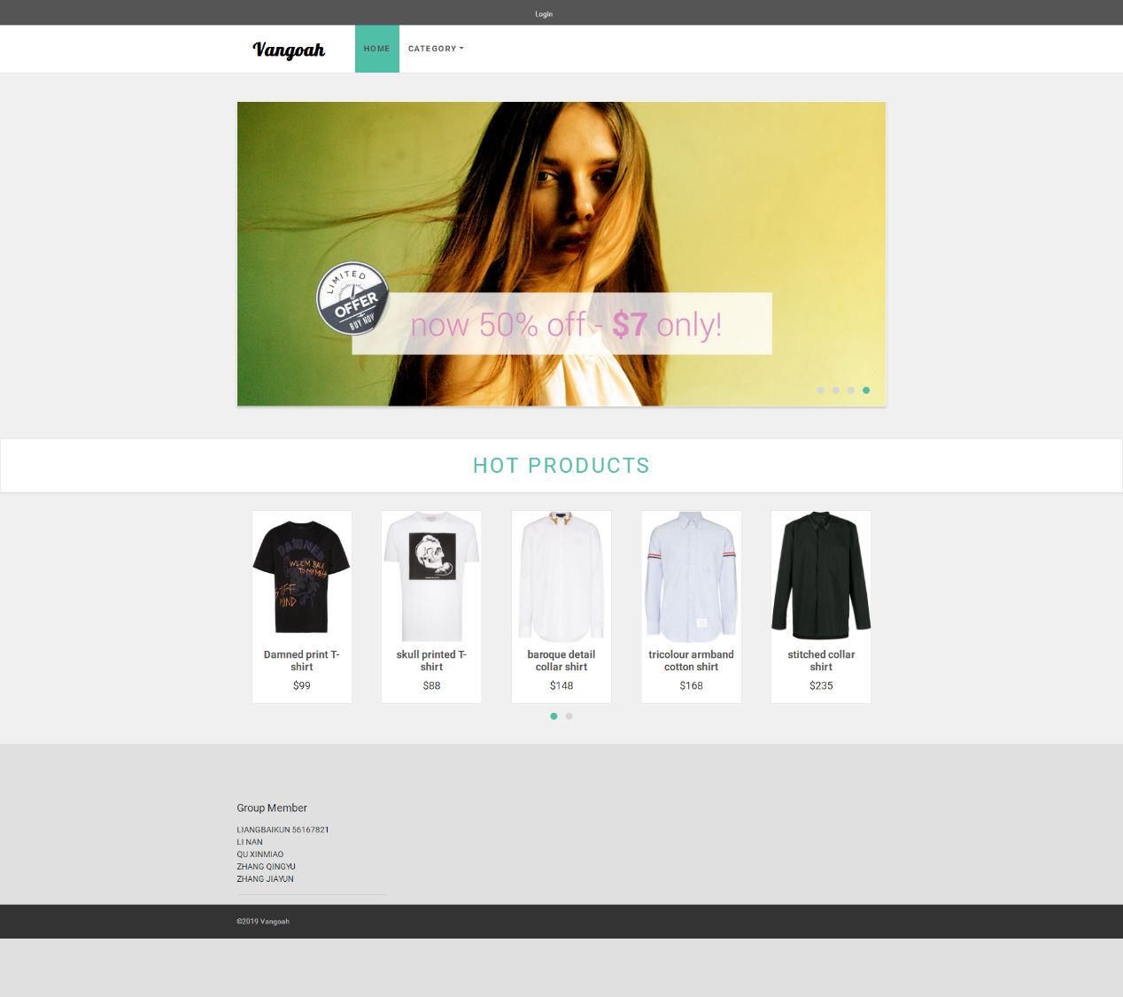

1. Vendor details page

All products are sorted by product ID automatically. Users can also sort the products by price or product name by changing the SORT BY button.

By clicking different category buttons on the left side, users can see all products under the category they choose. There are 4 main categories: Men, Women, Boys and Girls, and their sub-categories: T-shirts, Shirts, Pants and Jeans.

Users can move to the detail page for each item by clicking the VIEW DETAIL button, or they can click the ADD TO CART button directly to proceed to the shopping cart page. 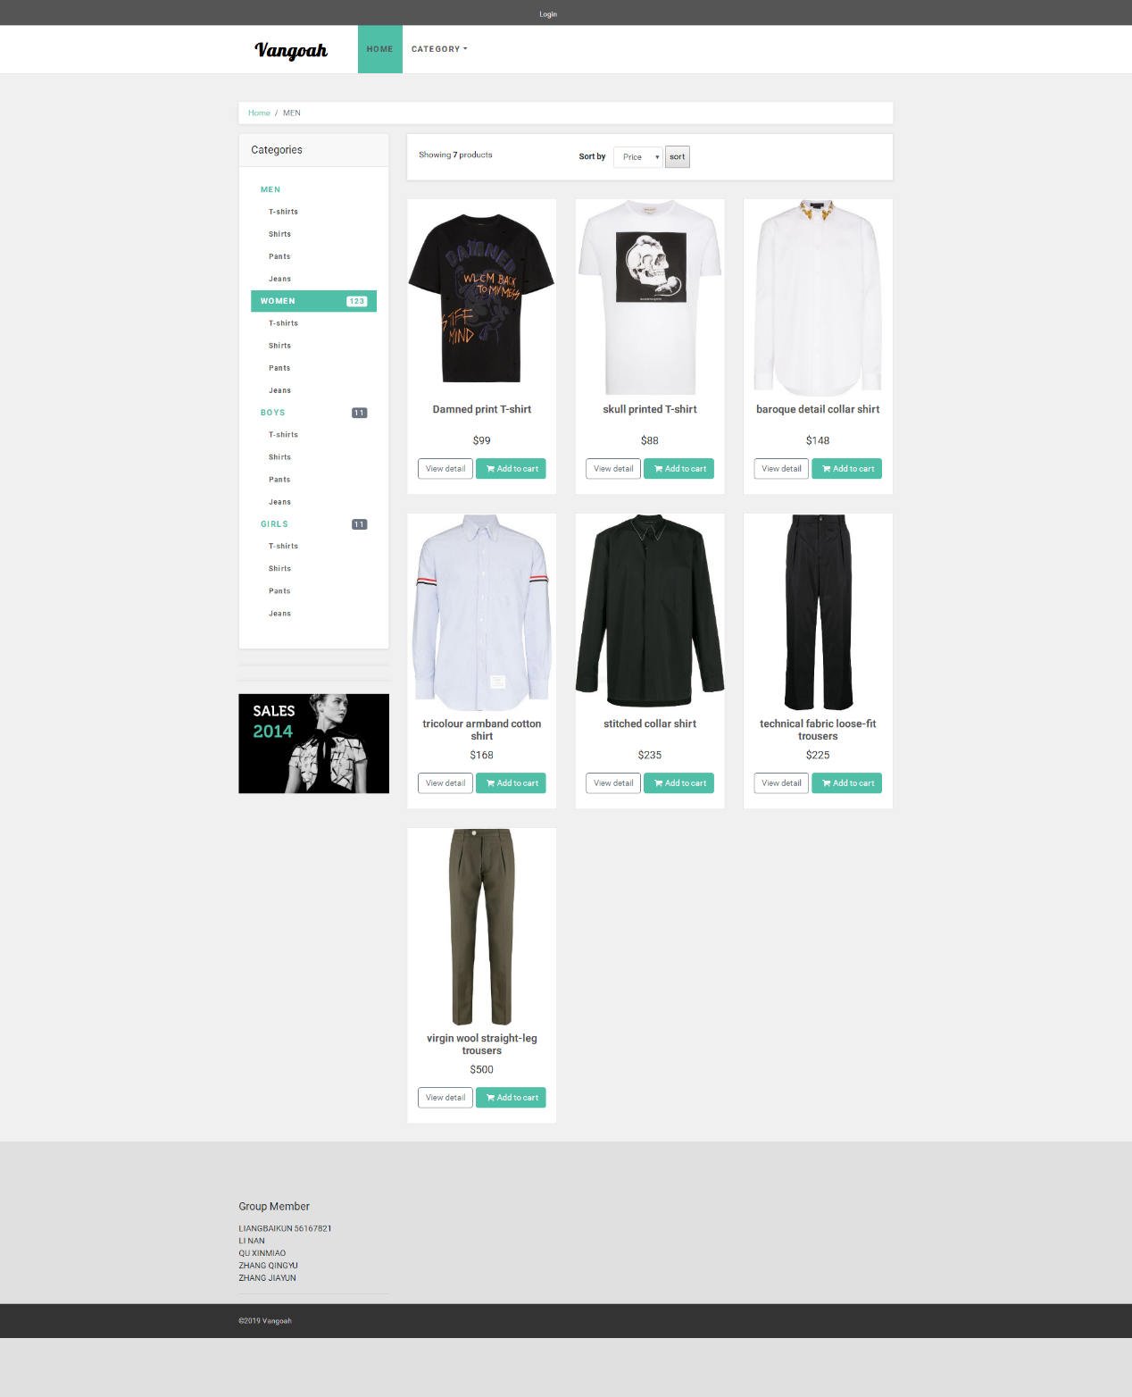

1. Details page

This page shows the details description for each item. Users can proceed to checkout directly in this page.

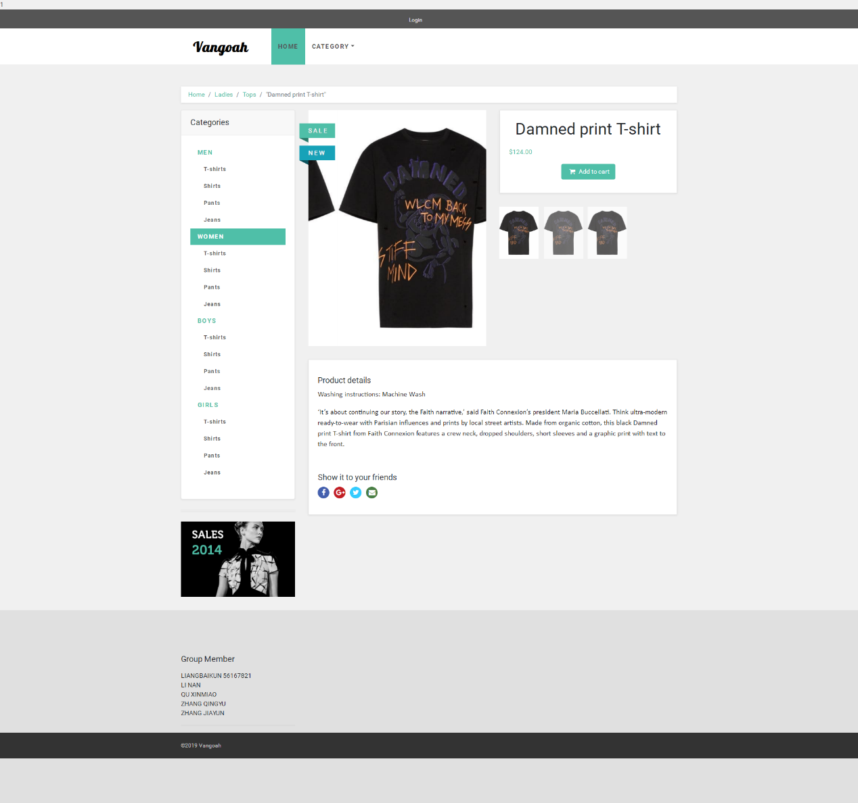

1. Shopping cart page

Users can choose the quantity for each item when logged in. Otherwise, it will turn to the Login page instead.

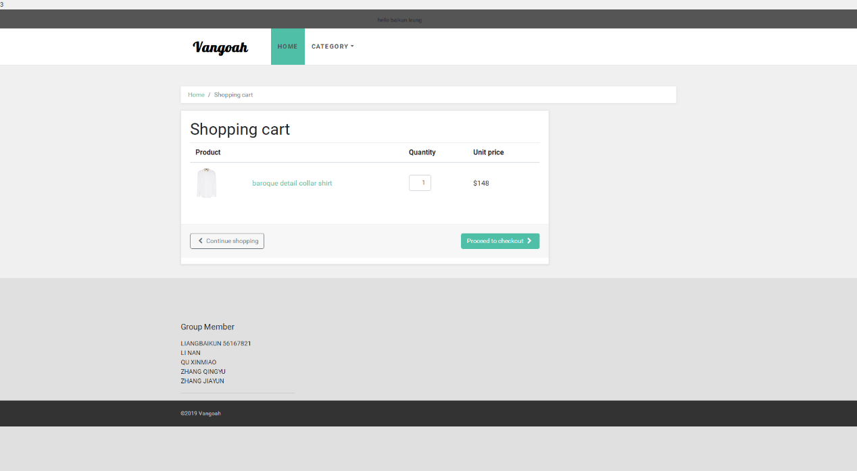

1. Checkout page

The following four pages show the personal information, delivery method, payment method, as well as the order summary.

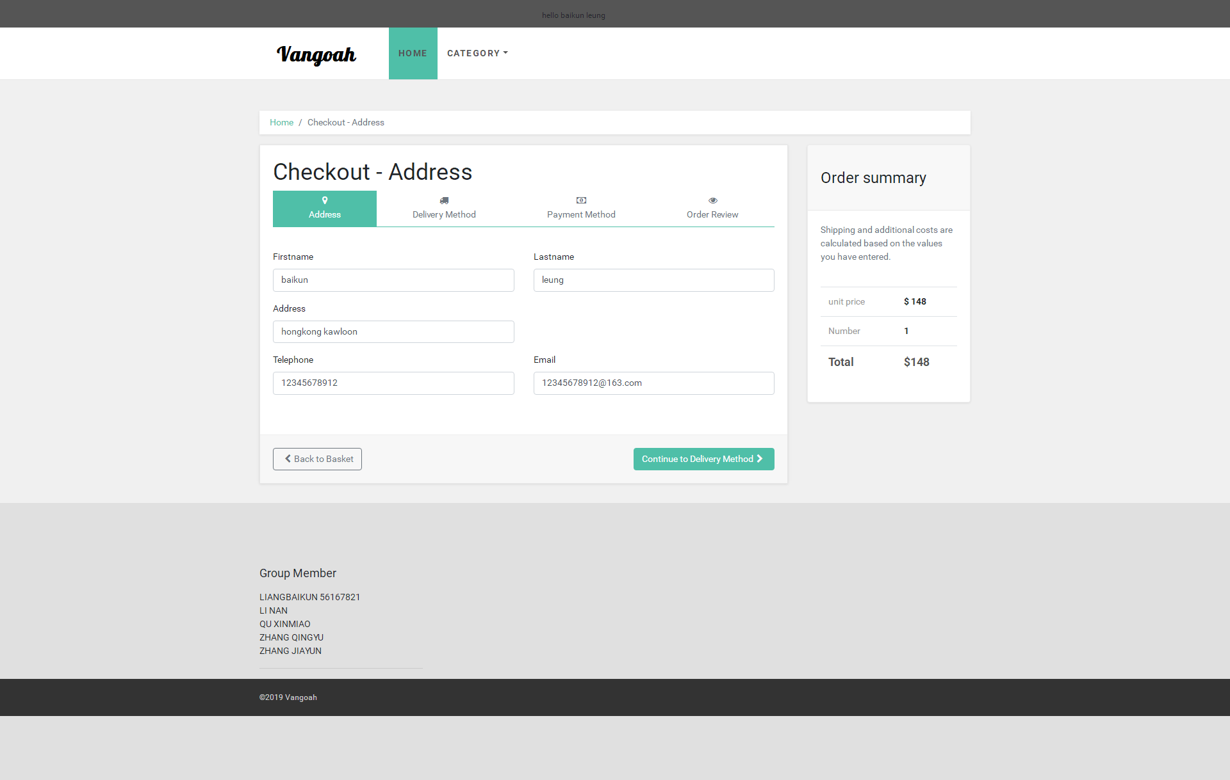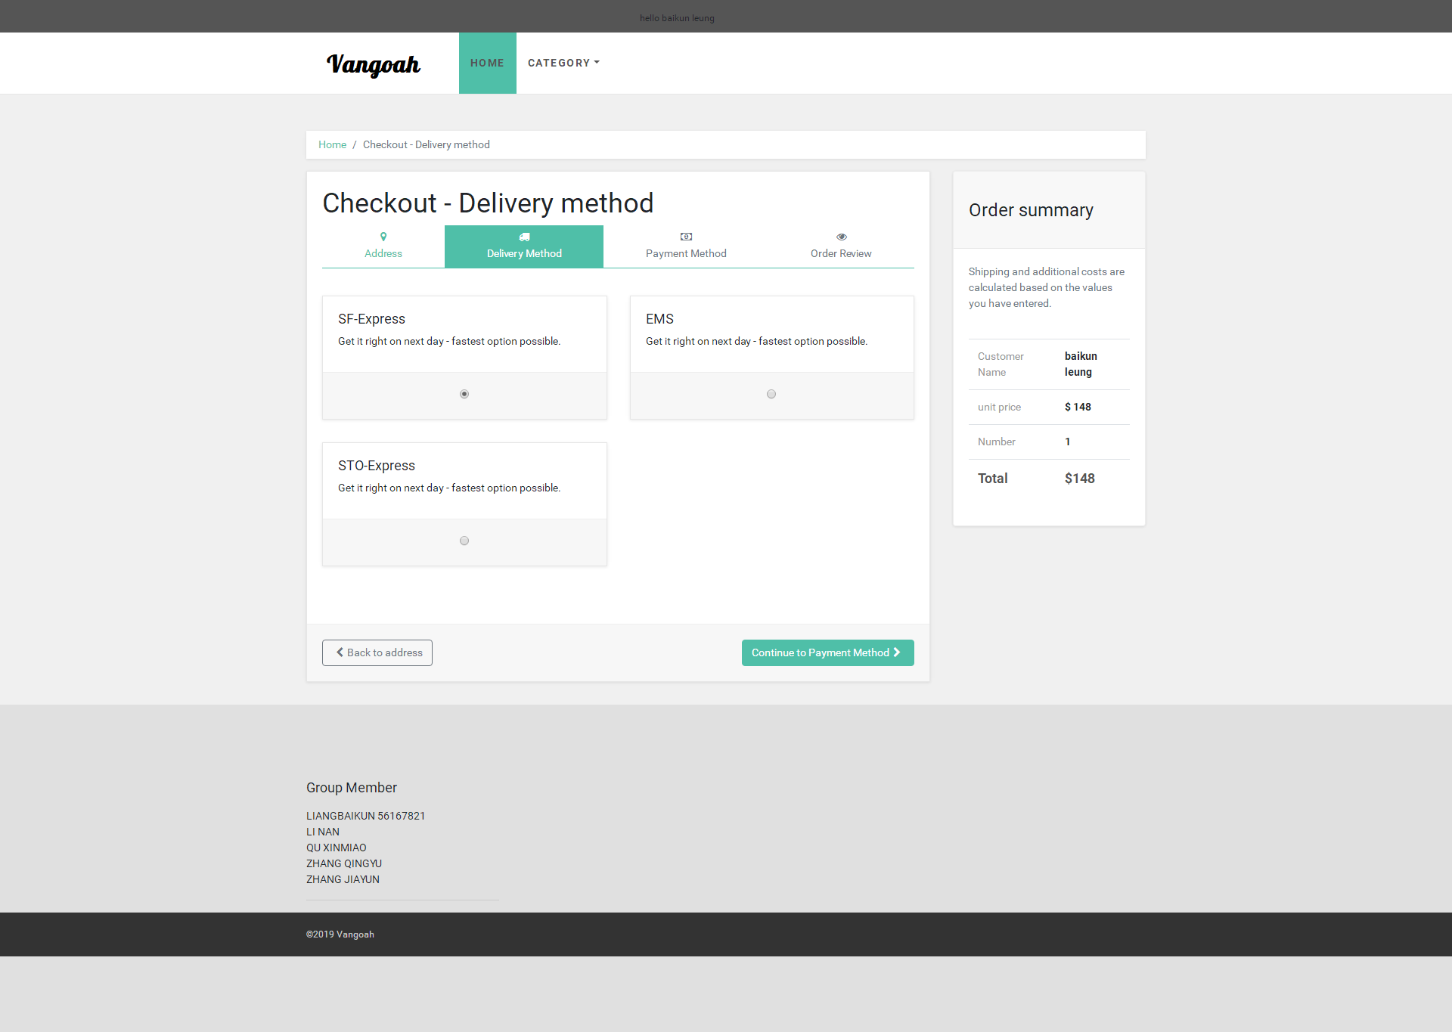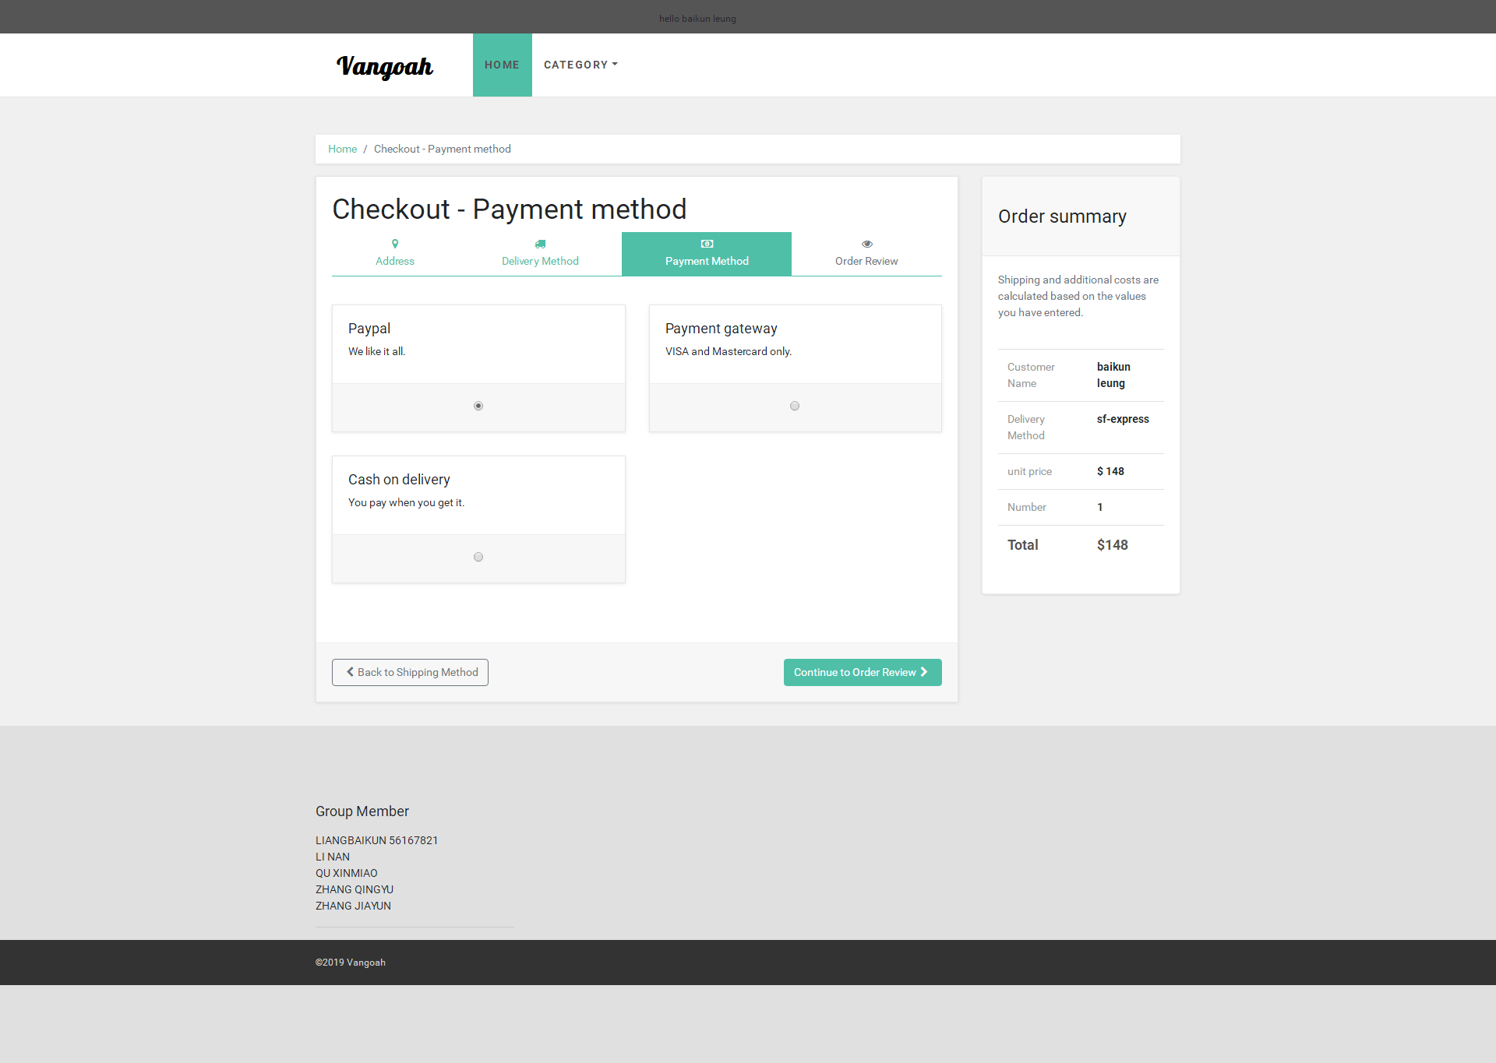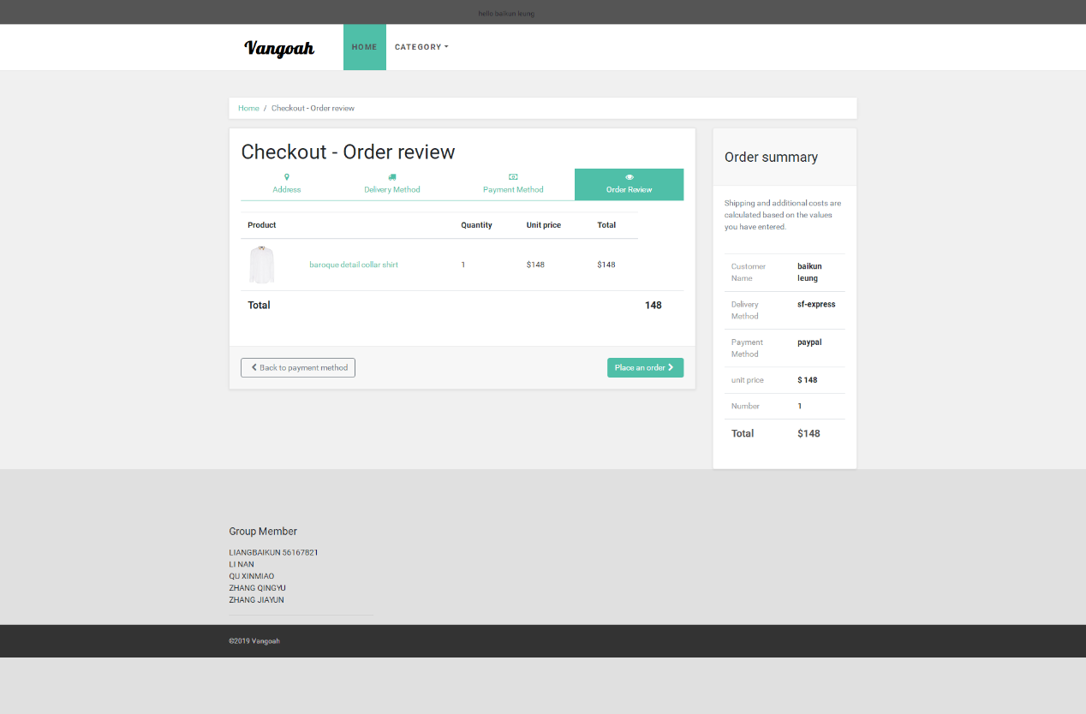

### Administrator

1. User Management page

The administrator can add, delete, modify or search user information in the following pages.

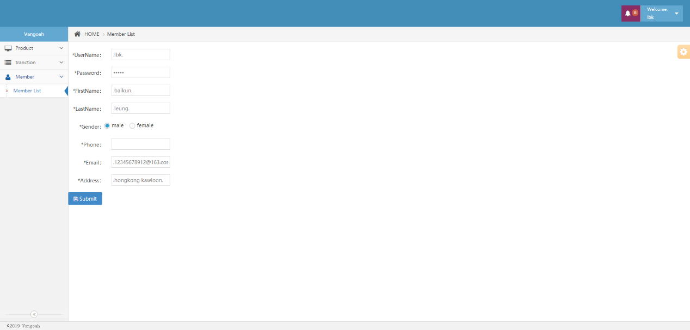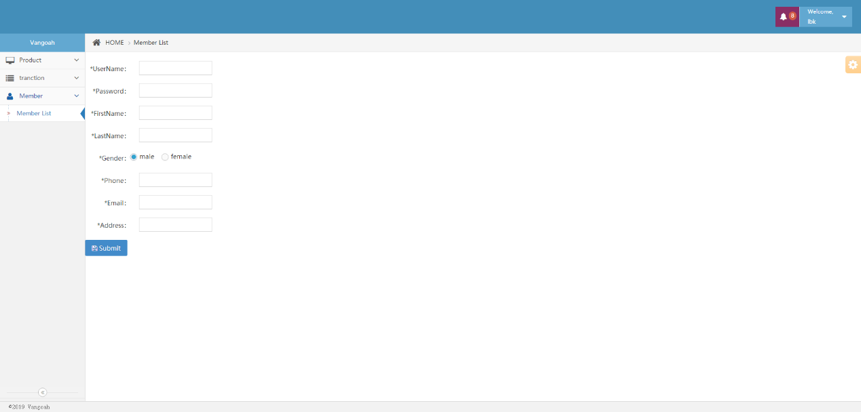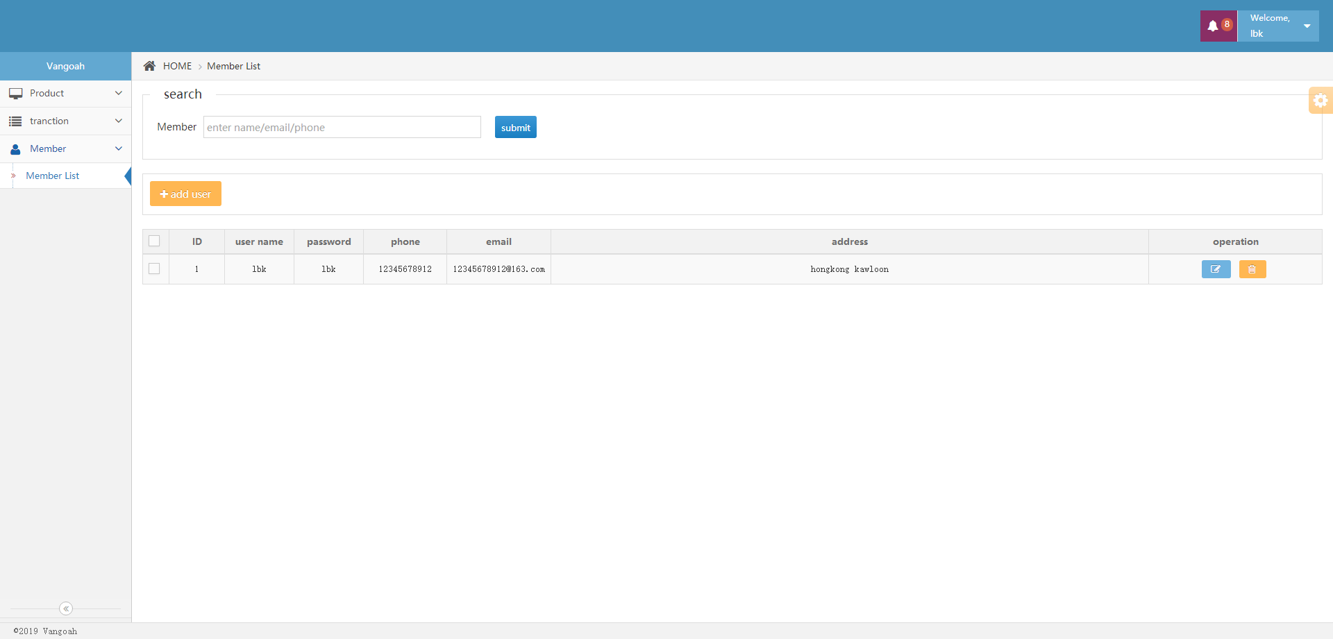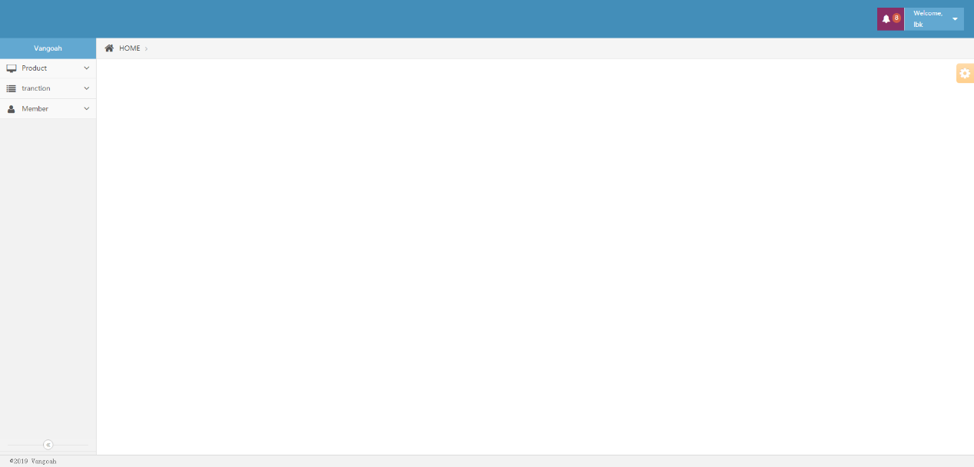

1. Product Management page

The administrator can add, delete, modify or search product information in the following pages.

